
NATIONAL INSTITUTE OF TRANSPORT

DEPARTMENT OF COMPUTING AND COMMUNICATION TECHNOLOGY
PROGRAM : HIGHER DIPLOMA IN INFORMATION TECHNOLOGY
MODULE NAME : DISTRIBUTED SYSTEMS
MODULE CODE : ITU 08106
LECTURE’S NAME : SARAH FLORENCE
ACADEMIC YEAR : 2025/2026
GROUP NUMBER : 07
TASK : GROUP ASSGINMENT 03
S/N | NAME | REG NUMBER | SIGNATURE
1 | COLETHA PAULO | NIT/BIT/2023/2089
2 | WAHABI BUKURU | NIT/BIT/2023/2115
3 | FATUMA YUSUPH | NIT/BIT/2023/2224
4 | JEREMIA MASABURI | NIT/BIT/2023/2041
5 | ASTERIA MWALYENGA | NIT/BIT/2023/2046
6 | AYUBU MSOKOLO | NIT/BIT/2023/2225
7 | FLORIDA MAYALLA | NIT/BIT/2023/2208
8 | GEOFREY KANDEA | NIT/BIT/2023/2243
9 | EMANUEL DAKHO | NIT/BIT/2023/2158
10 | SHADRACK MWASAMYA | NIT/BIT/2023/2199
11 | DIDAS MALISAWA | NIT/BIT/2023/2240
12 | AVINUS R ADABERT | NIT/BIT/2023/2351
13 | NASIBU ATHUMANI | NIT/BIT/2023/2273
14 | FRANK GODFREY | NIT/BIT/2023/2328
15 | REVOCATUS KAJANA | NIT/BIT/2023/2330
16 | WILIAM MVUNGI | NIT/BIT/2023/2226

QUESTIONS
- Design Peer-to-peer systems Using network programming.
- Describe the Design of Cloud computing such as Google case study; Big Data paradigm in enhancing computing capacity and resource sharing.
QUESTION 02.
Cloud computing is a distributed computing model that provides scalable computing resources such as storage, processing power, and applications over the Internet.
Google is a leading example of large-scale cloud computing design
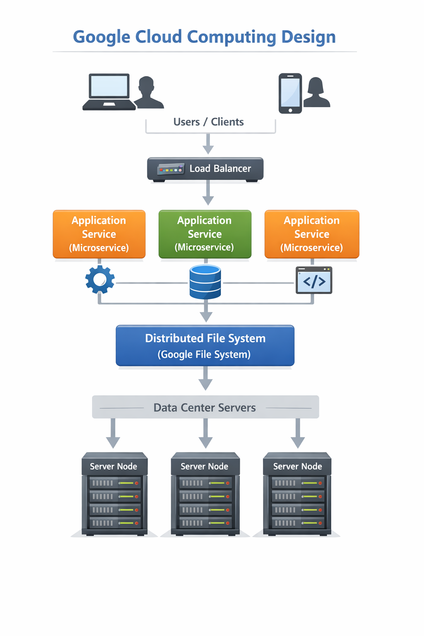
Google Cloud Computing Design
Google’s cloud architecture is built on a global network of distributed data centers.
Key design components include:
- Massive data centers located in different regions around the world
- Thousands of interconnected servers using high-speed networks
- Virtualization and containerization technologies to allocate resources efficiently
- Microservices architecture that allows independent deployment and scaling of services
To ensure reliability and performance:
- Google uses distributed file systems such as Google File System (GFS)
- Data is replicated across multiple machines for fault tolerance
- Load balancers distribute client requests across servers
- Monitoring systems detect failures and automatically reassign tasks to healthy nodes
This design ensures high availability, scalability, and efficient resource utilization.

Big Data Paradigm in Enhancing Computing Capacity and Resource Sharing
The Big Data paradigm focuses on processing very large datasets using distributed computing techniques.
Main ideas include:
- Large datasets are divided into smaller tasks
- Tasks are processed in parallel across many machines
- Results from individual machines are combined to form the final output
Google uses frameworks such as MapReduce to achieve this:
- Map phase processes data in parallel on multiple servers
- Reduce phase aggregates and combines results
Benefits of this approach:
- Enhances computing capacity by using many servers simultaneously
- Enables dynamic sharing of resources among applications
- Improves scalability, performance, and cost efficiency
- Supports real-time and large-scale data analysis

Example
Google Search uses Big Data techniques to process billions of web pages. Indexing and ranking tasks are distributed across thousands of servers using MapReduce, allowing fast, accurate, and reliable search results worldwide.

